**Data Structures Lab 8**

**Course:** Data Structures (CL2001) **Semester:** Fall 2024

**Instructor:** Shafique Rehman

**Note:**

* + - * Lab manual cover following below Advance sorting algorithms: **{Quick Sort, Merge Sort, Radix Sort}**
* Maintain discipline during the lab.
* Just raise your hand if you have any problem.
* Completing all tasks of each lab is compulsory.
* Get your lab checked at the end of the session.

**Quick Sort**

Quick Sort Algorithm is a **Divide & Conquer algorithm**. It divides input arrays in two partitions, calls itself for the two partitions (recursively) and performs in-place sorting while doing so. A separate partition () function is used for performing this in-place sorting at every iteration.

There are 2 Phases in the Quick Sort Algorithm.

**Division Phase:**

* Divide the array into 2 halves by finding the pivot point to perform the partition of the array.
* The in-place sorting happens in this partition process itself.

**Recursion Phase:**

* Call Quick Sort on the left partition
* Call Quick Sort on the right partition.

**Quick Sort Algorithm:**

* Make the right-most index value pivot
* Partition the array using pivot value
* Quicksort left partition recursively
* Quicksort right partition recursively

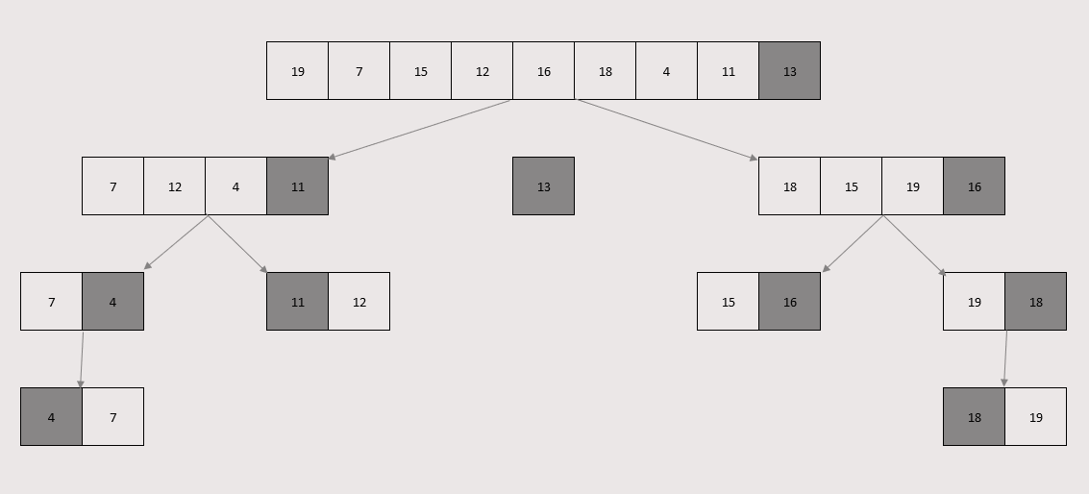

**Pivot Selection:**



* Choose the any index value as pivot
* Take two variables to point left and right of the list excluding pivot
* Left points to the low index & Right points to the high index
* While value at left is less than pivot move right & While value at right is greater than pivot move left
* If both left & right step does not match swap left and right
* If left = right, the point where they met is new pivot

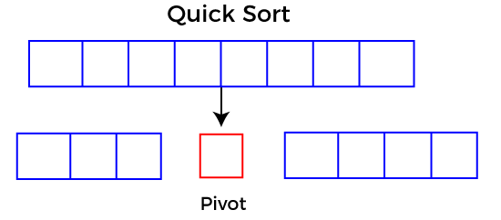

**Pseudocode:**

**function partitionFunc(left, right, pivot)**

**leftPointer = left**

**rightPointer = right - 1**

**while True do**

**while A[++leftPointer] < pivot do**

**//do-nothing**

**end while**

**while rightPointer > 0 && A[--rightPointer] > pivot do**

**//do-nothing**

**end while**

**if leftPointer >= rightPointer**

**break**

**else**

**swap leftPointer,rightPointer**

**end if**

**end while**

**swap leftPointer,right**

**return left pointer**

**end function**

**Time Complexity:**

Worst Case - O(N2) **|** Average Case - O(N LOG N) **|** Best Case - O(N LOG N)

**Merge Sort**

Merge sort is a sorting algorithm that follows the **divide-and-conquer approach**. It works by recursively dividing the input array into smaller subarrays and sorting those subarrays then merging them back together to obtain the sorted array. In simple word, it **continuously splits the array in half** until it cannot be further divided i.e., the array has **only one element left** (an array with one element is always sorted). Then the sorted subarrays are merged into one sorted array.

Merge sort is a popular sorting algorithm known for its efficiency and stability. It follows the **divide-and-conquer**approach to sort a given array of elements.

Here’s a step-by-step explanation of how merge sort works:

1. **Divide:**Divide the list or array recursively into two halves until it can no more be divided.
2. **Conquer:**Each subarray is sorted individually using the merge sort algorithm.
3. **Merge:**The sorted subarrays are merged back together in sorted order. The process continues until all elements from both subarrays have been merged.

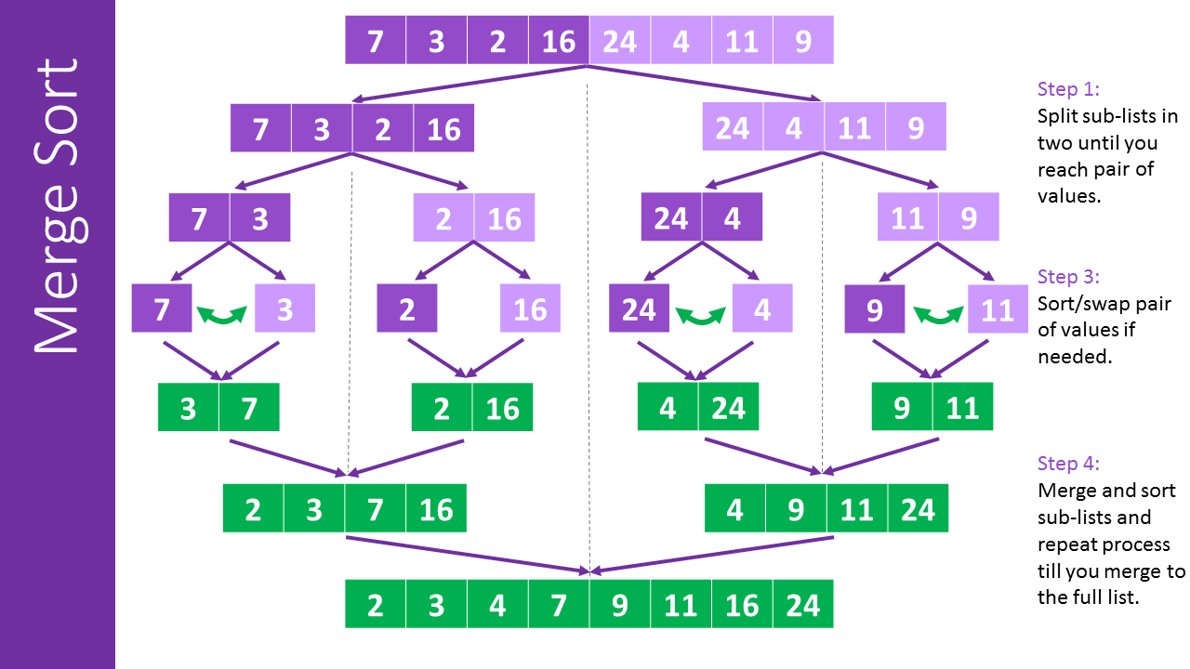



**Merge Sort Algorithm:**

* Divide the list recursively into two halves until it can no more be divided.
* Merge the smaller lists into new list in sorted order.

**Pseudocode:**

**function mergeSort(arr, left, right)**

**if left < right do**

**mid = left + (right - left) / 2**

**mergeSort(arr, left, mid)**

**mergeSort(arr, mid + 1, right)**

**merge(arr, left, mid, right)**

**end if**

**end function**

**function merge(arr, left, mid, right)**

**n1 = mid - left + 1**

**n2 = right - mid**

**leftArr[n1], rightArr[n2]**

**for i = 0 to n1 - 1 do**

**leftArr[i] = arr[left + i]**

**end for**

**for j = 0 to n2 - 1 do**

**rightArr[j] = arr[mid + 1 + j]**

**end for**

**i = 0, j = 0, k = left**

**while i < n1 and j < n2 do**

**if leftArr[i] <= rightArr[j] then**

**arr[k] = leftArr[i]**

**i = i + 1**

**else**

**arr[k] = rightArr[j]**

**j = j + 1**

**end if**

**k = k + 1**

**end while**

**while i < n1 do**

**arr[k] = leftArr[i]**

**i = i + 1**

**k = k + 1**

**end while**

**while j < n2 do**

**arr[k] = rightArr[j]**

**j = j + 1**

**k = k + 1**

**end while**

**end function**

**Time Complexity:**

Worst Case - O(N LOG N) **|** Average Case - O(N LOG N) **|** Best Case - O(N LOG N)

**Radix Sort (Bucket Sort)**

Radix Sort is a linear sorting algorithm that sorts elements by processing them **digit by digit**. It is an efficient sorting algorithm for integers or strings with fixed-size keys. It is a **non-comparative sorting algorithm** and avoids comparison by creating and distributing elements into buckets according to their radix. For elements with more than one significant digit, this bucketing process is repeated for each digit, while preserving the ordering of the prior step, until all digits have been considered. For this reason, radix sort has also been called bucket sort and digital sort.

Here’s a step-by-step explanation of how radix sort works:

1. Take input array and find MAX number in the array
2. Define 10 queues each representing a bucket for each digit from 0 to 9.
3. Consider the least significant digit of each number in the list which is to be sorted.
4. Insert each number into their respective queue based on the least significant digit.
5. Group all the numbers from queue 0 to queue 9 in the order they have inserted into their respective queues.
6. Repeat from step 3 based on the next least significant digit.
7. Repeat from step 2 until all the numbers are grouped based on the most significant digit.

1. <https://www.youtube.com/watch?v=XiuSW_mEn7g>

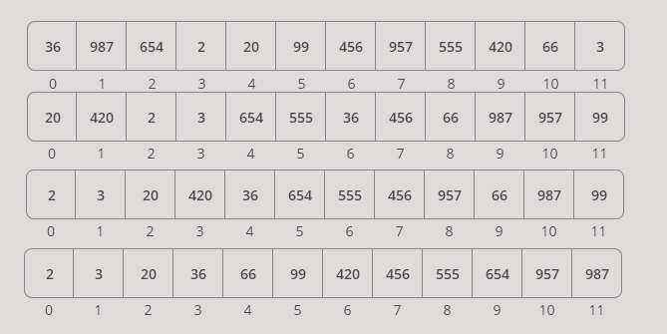

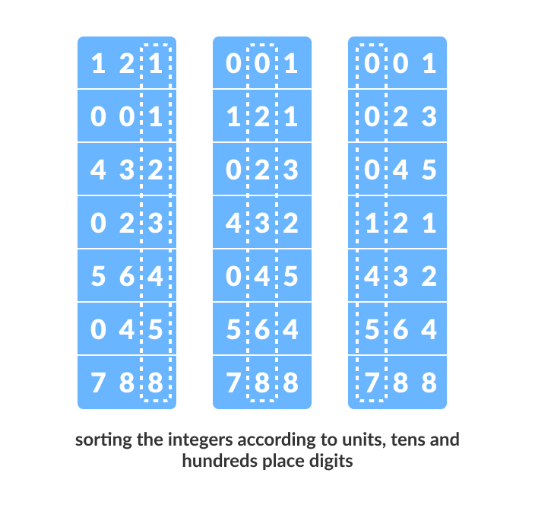

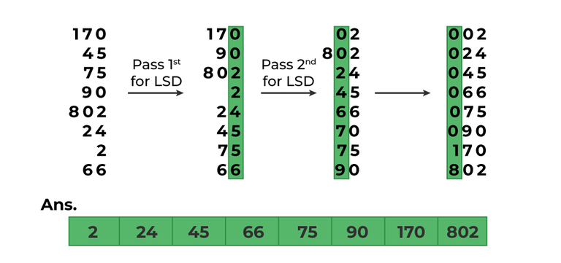

**Original Array:**

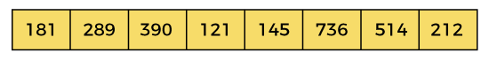

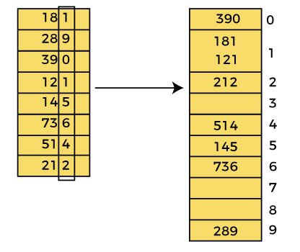**Pass 1: Pass 2:**

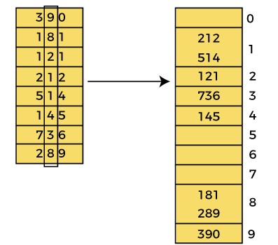

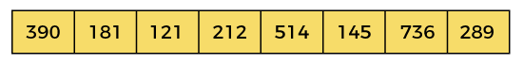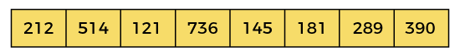

**Pass 3:**

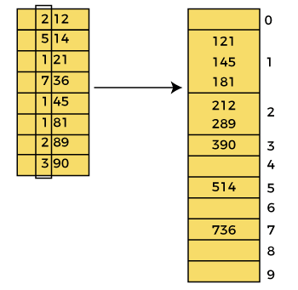

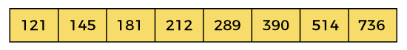

**Pseudocode:**

**function getMax(arr, n)**

**mx = arr[0]**

**for i = 1 to n - 1 do**

**if arr[i] > mx then**

**mx = arr[i]**

**end if**

**end for**

**return mx**

**end function**

**function countSort(arr, n, exp)**

**output[n]**

**count[10] = {0}**

**for i = 0 to n - 1 do**

**count[(arr[i] / exp) % 10] += 1**

**end for**

**for i = 1 to 9 do**

**count[i] += count[i - 1]**

**end for**

**for i = n - 1 downto 0 do**

**output[count[(arr[i] / exp) % 10] - 1] = arr[i]**

**count[(arr[i] / exp) % 10] -= 1**

**end for**

**for i = 0 to n - 1 do**

**arr[i] = output[i]**

**end for**

**end function**

**function radixsort(arr, n)**

**m = getMax(arr, n)**

**for exp = 1 to m do**

**countSort(arr, n, exp)**

**exp *= 10**

**end for**

**end function**

**Time Complexity:**

Worst Case - O(N * K) **|** Average Case - O(N * K) **|** Best Case - O(N + K)